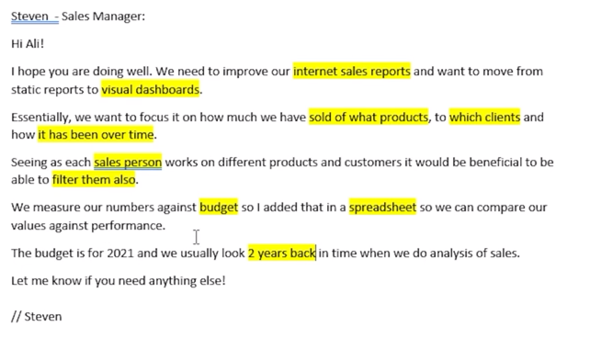

Business Demand:

- Reporter: Steven

- Value of Change: Visual dashboards and improved sales reporting or follow up for sales force

- Necessary Systems: Power BI, CRM System

- Other Relevant Info: Budgets have been delivered in Excel for 2021.

User Stories:

|  |  |  |  |  |
| --- | --- | --- | --- | --- |
| No# | As a (role) | I want (Request/Demand) | So that I (User value) | Acceptance criteria |
| 1 | Sales Manager | To get a dashboard overview of internet sales. | Can follow better which customers and products sells the best. | A Power BI dashboard which updates data once a day. |
| 2 | Sales Representative | A detailed overview of internet sales per customers. | Can follow up my customers that buys the most and who we can sell more to. | A Power BI dashboard which allows me to filter data for each customer. |
| 3 | Sales Representative | A detailed overview of internet sales per products. | Can follow up my products that sells the most. | A Power BI dashboard which allows me to filter data for each product. |
| 4 | Sales Manager | A dashboard overview of internet sales. | Follow sales over time against budget. | A Power BI dashboard with graphs and KPIs comparing against budget. |

In data warehousing, fact tables and dimension tables work together to organize and analyze data effectively:

|  |  |
| --- | --- |
| Fact Table | Dimension Table |
| Stores quantitative data like sales amounts, quantities, etc. | Stores descriptive data, providing context to the facts (who, what, where, when how). |
| Contains facts/ measures: Numeric data can be aggregated (total sales, revenue, etc).  Foreign Key: References to dimension tables, linking facts to context. | Contains attributes: descriptive data that provides more detail (eg: product name, category, customer name, etc.).  Primary key: A unique identifier for each record, which is referenced by the fact table. |
| **Granularity:** Represents transactional data, often at the lowest level of detail (e.g., each sale or transaction). | **Granularity:** Generally less detailed and more stable over time compared to fact tables. |
| **Example:** A sales fact table might include columns for Sales_Amount, Quantity_Sold, Date_ID, Product_ID, and Store_ID. | **Example:** A product dimension table might include columns for Product_ID, Product_Name, Category, Brand, and Supplier. |

Necessary tables to use:

* Internet sales reports.
* What products.
* Which clients.
* Sales person.
* Budget.
* 2 years back.